Title … “Arial, 12 point, bold”

^{1*}Name Surname, ²Name Surname, ³Name Surname, “Arial, 9 point”
¹ University, Faculty, Department, Adress, “Arial, 9 point”
² University, Faculty, Department, Adress, “Arial, 9 point”
³ University, Faculty, Department, Adress, “Arial, 9 point”

* E-mail: xxx@yyy.com“Arial, 9 point”

Abstract
“Arial, 10 point, max 300 words”.. The abstract should be written in English.

Key Words: key1, key2, key3.

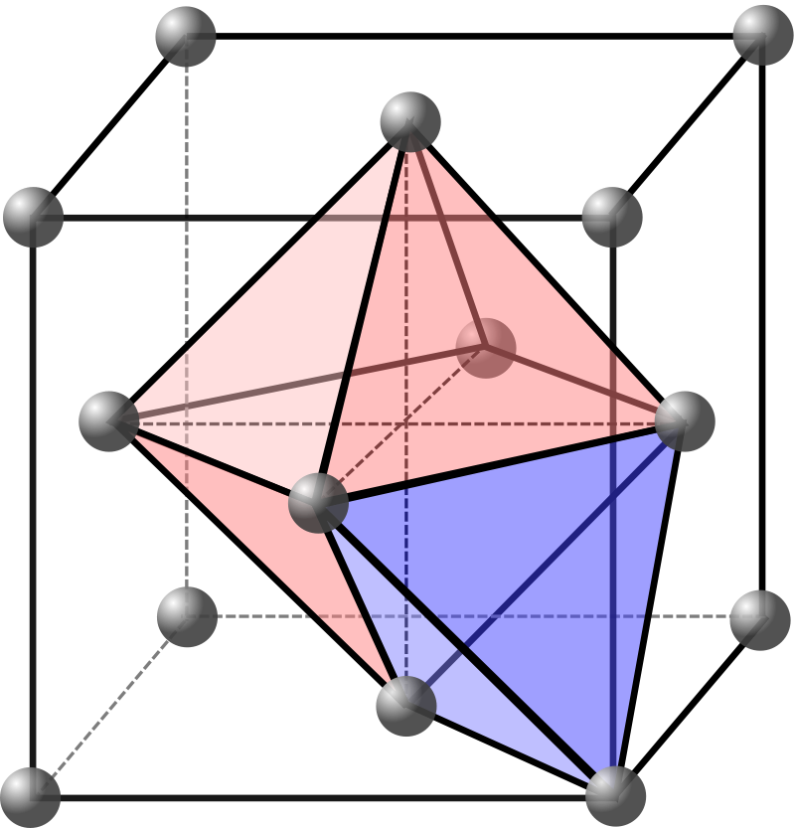
Fig. 1:“Arial, 9 point, centered,

References
Prince, E. (2006). International Tables for Crystallography Vol. C: Mathematical, Physical and Chemical Tables. Wiley. ISBN 978-1-4020-4969-9. OCLC 166325528. OL 9332669M. Archived from the original on 6 May 2022.

