**Title … “Arial, 12 point, bold”**

1*Name Surname, 2Name Surname, 3Name Surname, “Arial, 9 point”

1 University, Faculty, Department, Adress, “Arial, 9 point”

2 University, Faculty, Department, Adress, “Arial, 9 point”

3 University, Faculty, Department, Adress, “Arial, 9 point”

* E-mail: xxx@yyy.com“Arial, 9 point”

**Abstract**

“Arial, 10 point, max 300 words”.. The abstract should be written in English.

**Key Words:** key1, key2, key3.

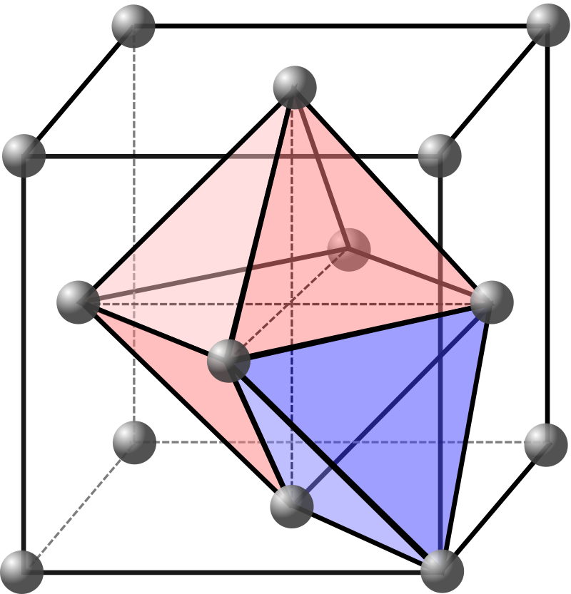

Fig. 1:“Arial, 9 point, centered,

**References**

Prince, E. (2006). International Tables for Crystallography Vol. C: Mathematical, Physical and Chemical Tables. Wiley. ISBN 978-1-4020-4969-9. OCLC 166325528. OL 9332669M. Archived from the original on 6 May 2022.